Mark hilliker

Chen

CSE 445

14 June 2015

Assignment 3

System Diagram

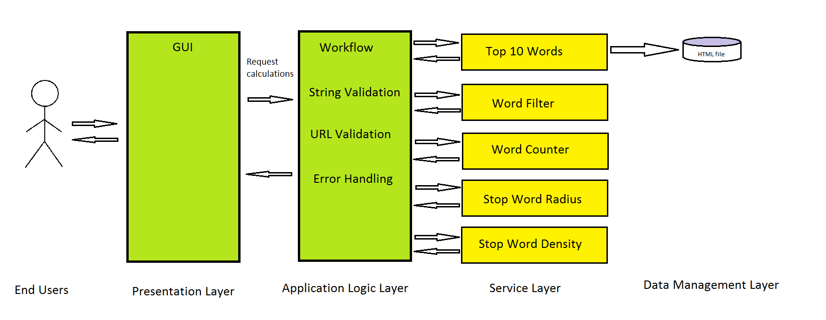

Service Table

|  |  |  |  |  |
| --- | --- | --- | --- | --- |
| This page is deployed at: Fill out the address later submission. | | | | |
| This project is developed by: Mark Hilliker | | | | |
| Provider name | Service name, with input and output types | TryIt link | Service description | Planned resources need to implement the service |
| Mark Hilliker | Top10Words:  Input: String Output: String array | TryIt | Finds top 10 words in html page | Use web2string service at:  <http://venus.eas.asu.edu/WsRepository/Services/Web2StringSVC/Service.svc> |
| Mark Hilliker | WordFilter Inputs: String Output: String | TryIt | Removes stopwords from string. Also removes html and xml tags if it is that type ex:  <!DOCTYPE html> | list of English stop words found at: <http://xpo6.com/list-of-english-stop-words/> |
| Mark Hilliker | WordCount Input:  string text,  string keyword Output: integer | TryIt | Counts number of occurrences of a keyword in a string | None |
| Mark Hilliker | StopRadius  Input:  string text,  string keyword  Output: double | TryIt | Finds the average radius of the first occurrence of a stop word from a keyword in a given string. | list of English stop words found at: <http://xpo6.com/list-of-english-stop-words/> |
| Mark Hilliker | StopDensity  inputs:  string text,  integer radius Output: double | TryIt | Finds the average density of stop words in a given string within a given cluster radius. Clusters will be chosen to maximize density without overlapping. | list of English stop words found at: <http://xpo6.com/list-of-english-stop-words/> |